Evaluating California’s stem cell experiment
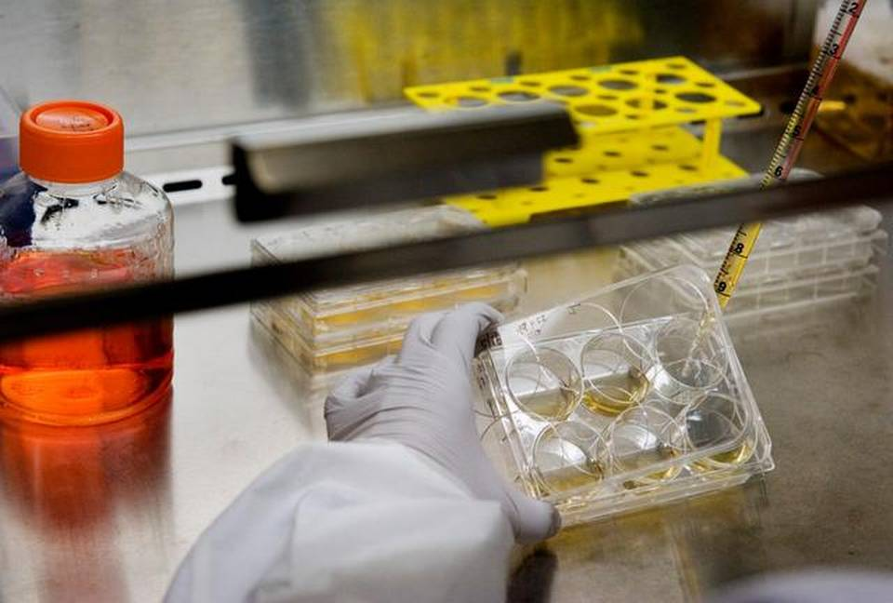
The California Institute for Regenerative Medicine expects to be taking part in 10 early-stage clinical trials this year, an achievement that it points to with pride; however, no California-financed cures or therapies have reached the clinic and none are likely to do so for years.
Twenty years ago, a 341-pound football player smashed into Roman Reed during a Chabot College game in Hayward, breaking the 19-year-old’s neck and changing his life inalterably.
Reed lost nearly all of his ability to move his body. But since then – with hard, hard work and good fortune – he has regained many of his skills. Although he still must use a wheelchair, he chauffeurs his three children to baseball games and sends out their photos on Facebook. He travels around California and the nation, advocating for patients like himself.
Reed’s favorite cause may well be California’s $3 billion stem cell program, which marks its 10th anniversary this month. He came up with the agency’s motto: “Turning stem cells into cures.” Its success or failure is much on Reed’s mind. Just recently, he described the state stem cell agency as a “beacon of hope” that will lead to cures for afflictions that affect nearly 50 percent of California families.
Today, however, no California-financed cures or therapies have reached the clinic and none are likely to do so for years, if then. The agency is spending money at a rate of $21,000 an hour, 24 hours a day, seven days a week. More than $1.8 billion has been awarded, with 88 percent of it going to institutions linked to persons who are or have been on the agency’s board of governors, according to calculations by the California Stem Cell Report, a website that has followed the agency since 2005. UC Davis, which has a seat on the board, has received $125.8 million, ranking fifth among recipients.
By the end of this year, the California Institute for Regenerative Medicine, called CIRM, expects to be taking part in 10 early-stage clinical trials, an achievement that it points to with pride. However, a study in Nature Biotechnology this year shows that even with conventional treatments, only one out of every 10 to enter trials emerges as a widely available, commercial product.
California’s research effort was created in 2004 when voters approved Proposition 71 following a $35 million campaign funded by Hollywood celebrities and Silicon Valley luminaries. The ballot initiative established CIRM and provided it with $3 billion through state bonds. The interest on that cash will cost roughly another $3 billion, the state legislative analyst says.
The Proposition 71 campaign was fundamentally driven by hope and the promise of seemingly miraculous cures from pluripotent stem cells that have the capability to become any organ in the body.
“Few California initiatives have been as brazen in tugging at voters’ heartstrings. Christopher Reeve (the movie actor who portrayed Superman) appeared in TV ads – two weeks after his death. Michael J. Fox (an actor who has Parkinson’s disease) cut ads,” Bill Whalen, a research fellow at the Hoover Institution at Stanford University, wrote on his blog.
Fueling the 2004 campaign were restrictions by then-President George W. Bush on federal funding for research on human embryonic stem cells, which are pluripotent. Some people believe that the use of those few-days-old cells is the equivalent of taking a human life. The Bush restrictions drew outrage and despair from scientists and patient advocates like Reed.
The Golden State’s stem cell measure seemed to be a big answer. Fund the research for 10 years, cap the number of stem cell agency employees at 50, draft top experts to set the priorities and programs, and, voilà, stem cell cures would materialize. Ignored during the campaign were the grindingly slow processes of scientific research and government regulators, who must rule on the safety and effectiveness of new therapies.
Last January, one supporter of CIRM, Jim Lott, told the agency’s top executives that it had failed to measure up to the expectations of voters. The occasion was a meeting of the Citizens Financial Accountability and Oversight Committee, the only state entity charged with overseeing the agency.
Lott is a member of the oversight committee and has served on it since at least 2006. He has a 13-year-old daughter with a spinal-cord injury. According a transcript of the meeting, he asked CIRM Chairman Jonathan Thomas “what did we get” for the $3 billion. Lott was unhappy with the answer.
“I’m telling you, pal, I would have a hard time voting for it again,” he said to Thomas.
Others have opposed the effort since its inception, including Wesley J. Smith, an author and lawyer who writes on National Review Online. He calls it a “boondoggle” that was “sold to the voters in a blatantly mendacious campaign.”
Thomas, who has been chairman only since 2011, is a firm believer, however, in the CIRM dream. He cites the agency’s stepped-up push to drive research into the clinic as a key indicator of CIRM’s success. By the end of this year, the San Francisco-based agency will be helping to tackle afflictions ranging from heart disease to AIDS in the 10 clinical trials.
In a recent email, Thomas said, “By any standards this is a remarkable achievement. But this is really only the start. We have a pipeline of other truly promising therapies that we hope to move into clinical trials in people in the next few years.”
The prestigious Institute of Medicine, in a $700,000, 17-month study commissioned by CIRM, said in December 2012 that CIRM has achieved “many notable results” and done “a remarkably good job” in giving the state a prominent position in stem cell medicine.
The blue-ribbon panel also said, “The challenge of moving its research programs closer to the clinic and California’s large biotechnology sector is certainly on CIRM’s agenda, but substantial achievements in this arena remain to be made.”
Since the Institute of Medicine report, the agency has moved forward with its clinical trial efforts. Nonetheless, the agency missed out on helping to initiate three major stem cell developments over the last 10 years, including the successful reprogramming of adult stem cells and a human embryonic stem cell trial for blindness at UCLA. It was not fully on board until very late with the on-again, off-again, first-ever human embryonic stem cell trial. That was a project abandoned by Geron Corp. for financial reasons and then revived by Asterias Biotherapeutics Inc., both of Menlo Park.
One of the issues that has dogged the research effort as far back as the 2004 campaign involves conflicts of interest. The board was structured in the initiative to give virtually all of the likely recipient institutions a seat at the table where the money is handed out. And in 2008 the journal Nature warned in an editorial of what it called “cronyism” in California.
More recently, Dale Carlson, a San Francisco publicist who once served as the agency’s chief communications officer for several years, commented, “Governance has always been CIRM’s Achilles’ heel. The board is ridiculously large and riddled with difficult-to-manage conflicts of interest.”
The Institute of Medicine study said: “Far too many board members represent organizations that receive CIRM funding or benefit from that funding. These competing personal and professional interests compromise the perceived independence of the ICOC (the CIRM governing board), introduce potential bias into the board’s decision making and threaten to undermine confidence in the board.”
The board did move to modify its procedures somewhat in response to the report, but the directors still control the game for grant-making.
Over the years, several conflict-of-interest cases have emerged. The most recent came last summer, surprising and shocking the agency. Its former president, Alan Trounson, took a position in July on the board of directors of Newark-based StemCells Inc. just seven days after leaving CIRM.
StemCells Inc. has received $19.4 million from CIRM. It was co-founded by renowned stem cell scientist Irv Weissman of Stanford University, who sits on its board and who held more than 200,000 shares of the company’s stock as of last spring. Weissman has received more than $30 million from the agency for research at Stanford, which holds a seat on the CIRM board.
In 2013, directors of StemCells Inc. received from $60,800 to $99,800 in total compensation, according to federal filings.
Following the disclosure and a wave of bad publicity, the new president of the agency, C. Randal Mills, signed a pledge that he would not accept employment with any award recipient for at least a year after he leaves the agency. However, the agency did not set restrictions on future employment by other agency employees.
CIRM board members, who are appointed by various public officials, rarely express public displeasure with the agency’s progress. In the past few years, however, they have felt pressure to fulfill the expectations of voters. Former Hollywood studio executive Sherry Lansing, a CIRM director and University of California regent, told fellow directors last December, “We need a home run.”
Asked for comment recently on the agency’s 10-year performance, several board members said CIRM is doing well.
Francisco Prieto, a Sacramento physician who has been on the board since late 2004, captured the essence of their views. He said stem cell science will “transform medicine and make the things I do every day look as primitive as leeches and blood-letting.”
Zach Hall was the first president of the agency, serving until 2007. In response to a question, he said that CIRM has been an “unqualified success” scientifically. It constituted a “visionary investment” that will pay off for decades.
He also said, “With such a huge (some would say excessive) budget, not all the money was spent wisely. In addition, the agency was burdened with a cumbersome and conflicted governance structure whose difficulties consumed far too much of the agency’s time and energy.”
As for the future of the Golden State’s stem cell experiment, funds for new grants are scheduled to run out in 2020, although the date exceeds the 10-year timetable touted in 2004.
By 2020, CIRM hopes that the clinical trials will show results that will resonate with policymakers, the public or private backers and generate support for additional funding, be it private, public or a combination of both.
The verdict is still out, however, on whether the agency will be ultimately worth the roughly $6 billion that the people of California will have spent. The stem cell agency has made a major contribution to the field. But whether its efforts will finally help lead to a blockbuster therapy is another matter.
Questions also remain about how the research program fits with state spending priorities. Was it or is it the best use of $6 billion for the health of the people of California? Some say that building a top-notch network of community health clinics for the poor would do more.
Perhaps by 2020, the answers will be clearer. If not, the agency could wither away and become nothing more than an outdated provision in California’s state civil code and constitution.
But right now, for the people most seriously affected, Roman Reed said, “We need CIRM … the world’s greatest hope for medical cures.”
David Jensen has followed the agency since 2005, publishing more than 4,000 items on the California Stem Cell Report. For more information about the performance of the California Institute for Regenerative Medicine, go to californiastemcellreport.blogspot.com.
CALIFORNIA’S STEM CELL RESEARCH EFFORT
In 2004, voters approved an unprecedented stem cell research initiative, Proposition 71, that created the California Institute for Regenerative Medicine. The governor and Legislature are barred from tampering with the agency’s funding. Here is a look at the agency’s record to date.
▪ Total estimated cost: $6 billion ($3 billion for awards plus $3 billion interest)
▪ Total awards made to date (construction and research): $1.9 billion
▪ Number of grants and loans: 647
▪ Number of published research articles: 1,750
▪ Number of CIRM-backed clinical trials involving possible therapies: 10 expected by end of 2014
▪ Number of commercial therapies produced: 0
▪ Estimated date when money runs out: 2020
Top five recipient institutions
▪ Stanford University – $298.3 million
▪ UCLA – $215.3 million
▪ UC San Diego – $147.8 million
▪ UC San Francisco – $132.7 million
▪ UC Davis – $125.8 million
(All have seats on the agency’s governing board.)
Clinical Trials: Early-stage therapies being tested for safety
Here is a look at the targeted diseases in which possible therapies are being examined and the enterprises involved.
HIV – Calimmune, Tucson, Ariz.
HIV – City of Hope, Duarte
Heart disease – Capricor Therapeutics Inc., Beverly Hills
Solid tumors – UCLA
Solid tumors – Stanford
Leukemia – UC San Diego
Sickle Cell Anemia – UCLA
Diabetes – ViaCyte Inc., San Diego
Spinal cord injury – Asterias Biotherapeutics Inc., Menlo Park
Blindness-AMD – USC

